Daniel’s Music Store

Prepared for: Profess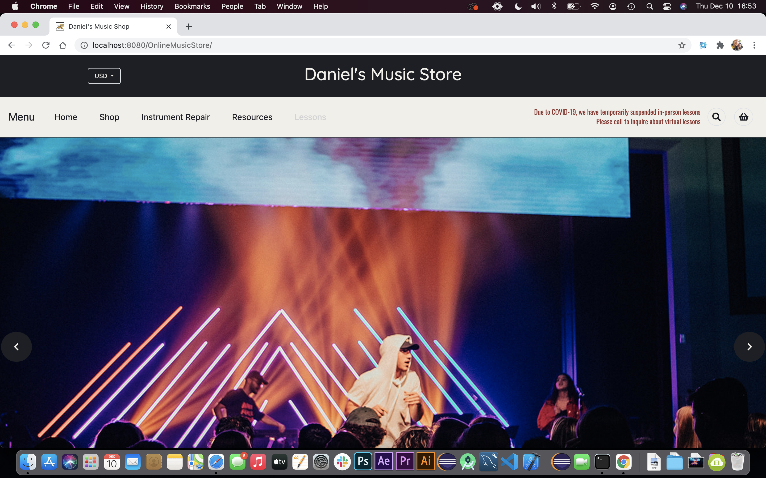or Lisa Macon

Daniel’s Music Store

Prepared by: Daniel Goins

December 10, 2020

# Executive Summary

## Objective

The website will be a place where a customer interacts with your company to request and/or purchase service(s) and/or product(s).  The website will return to the customer an invoice and/or request update. You will further code server side applications in PHP and client side in Javascript.  The intent is for you to use open source web technologies and showcase your scripting skills in one project.

Major areas of concentration for the project:

* Linux architecture
* Apache Tomcat
* Web server architecture
* PHP
* Javascript
* MySQL
* Usability of web applications

Daniel’s Music Store

* Testing and metrics for measuring
* Developing e-commerce sites

## Product

* The website features products with images and prices, as well as ratings from other customers.
* The website features sliders powered by JavaScript, courtesy of Slick (<https://kenwheeler.github.io/slick/>)
* The website features fonts from Font Awesome (<https://fontawesome.com/>)
* The website features Navigation Bars from Bootstrap (<https://getbootstrap.com/>)
* The website features a cart that initializes with one of all the products in the cart, able to remove items from the cart, and add to the quantity of the cart. The total updates as the quantity changes and products are removed.

# The project

First, the Apache Tomcat server deploys perfectly fine. The application is stored in a .war file, the file is then deployed using the Manager App on localhost, and the link then is used to go to the website.

Daniel’s Music Store

Once deployed, the website is organized, concise, and appealing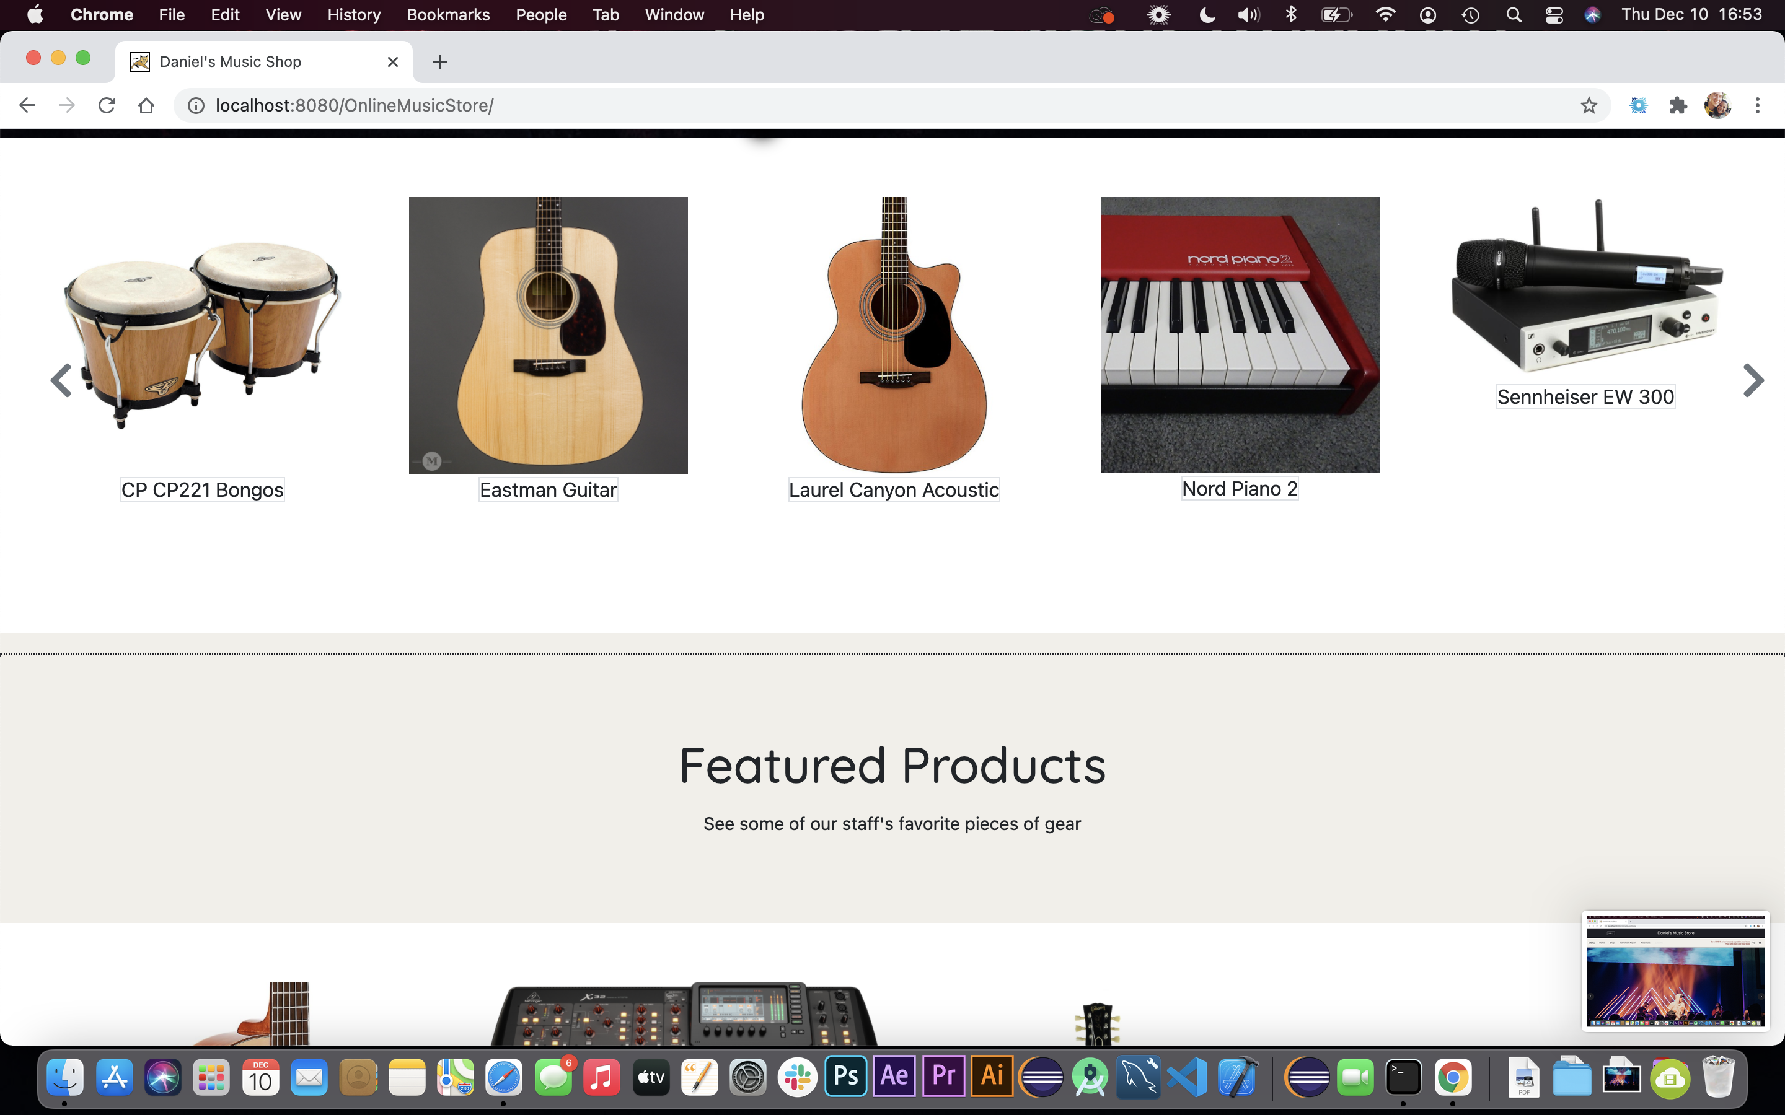

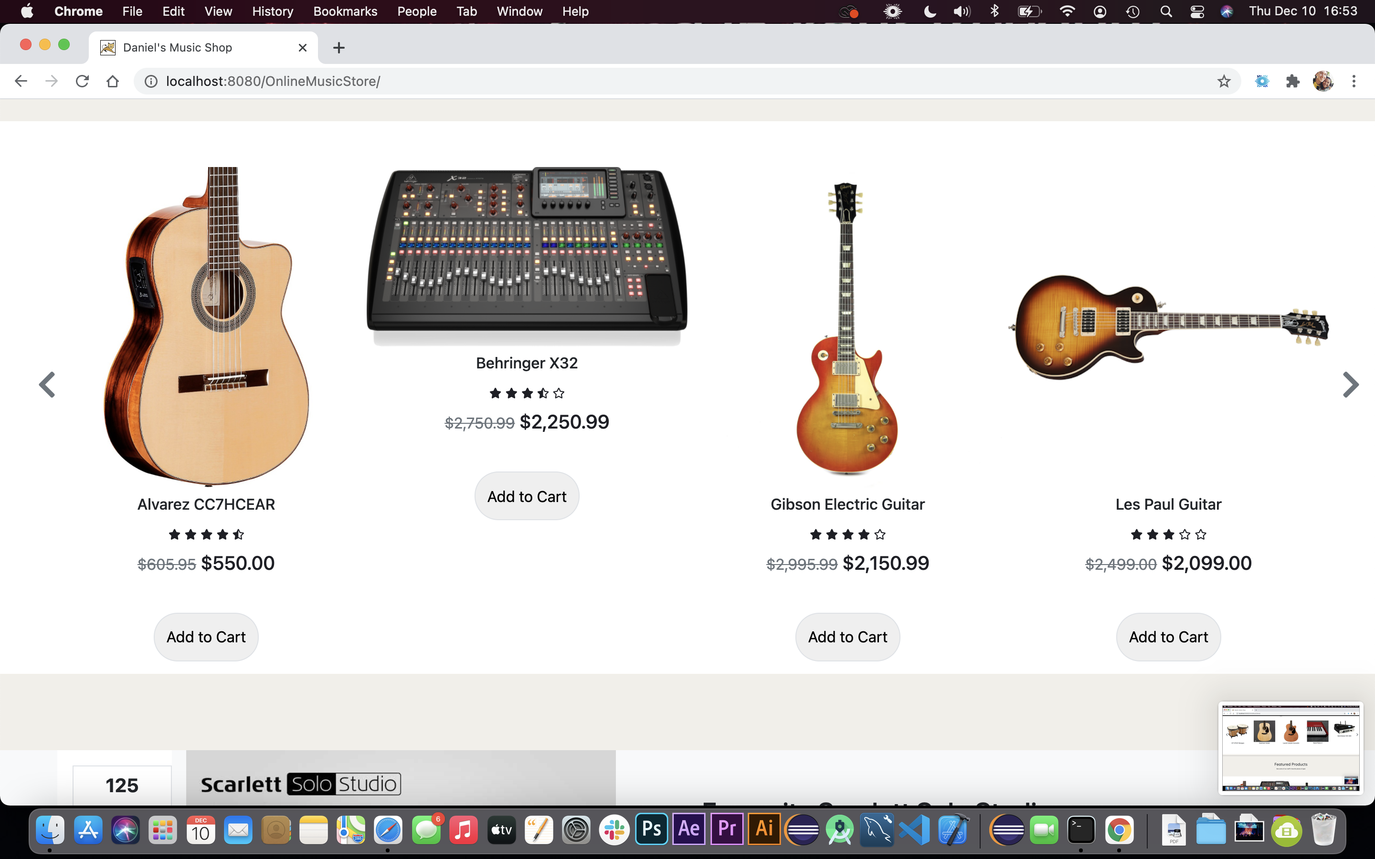

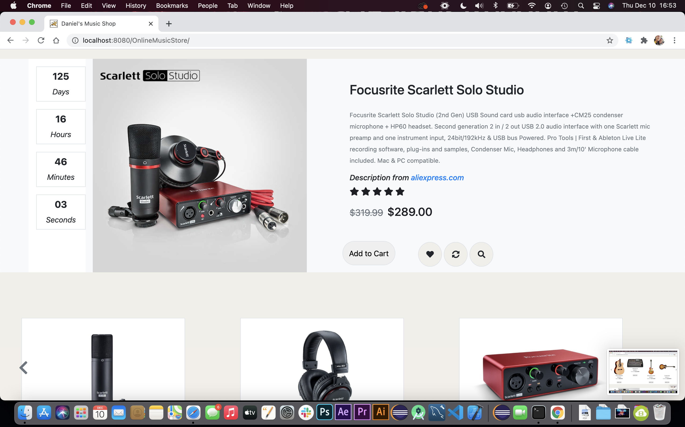

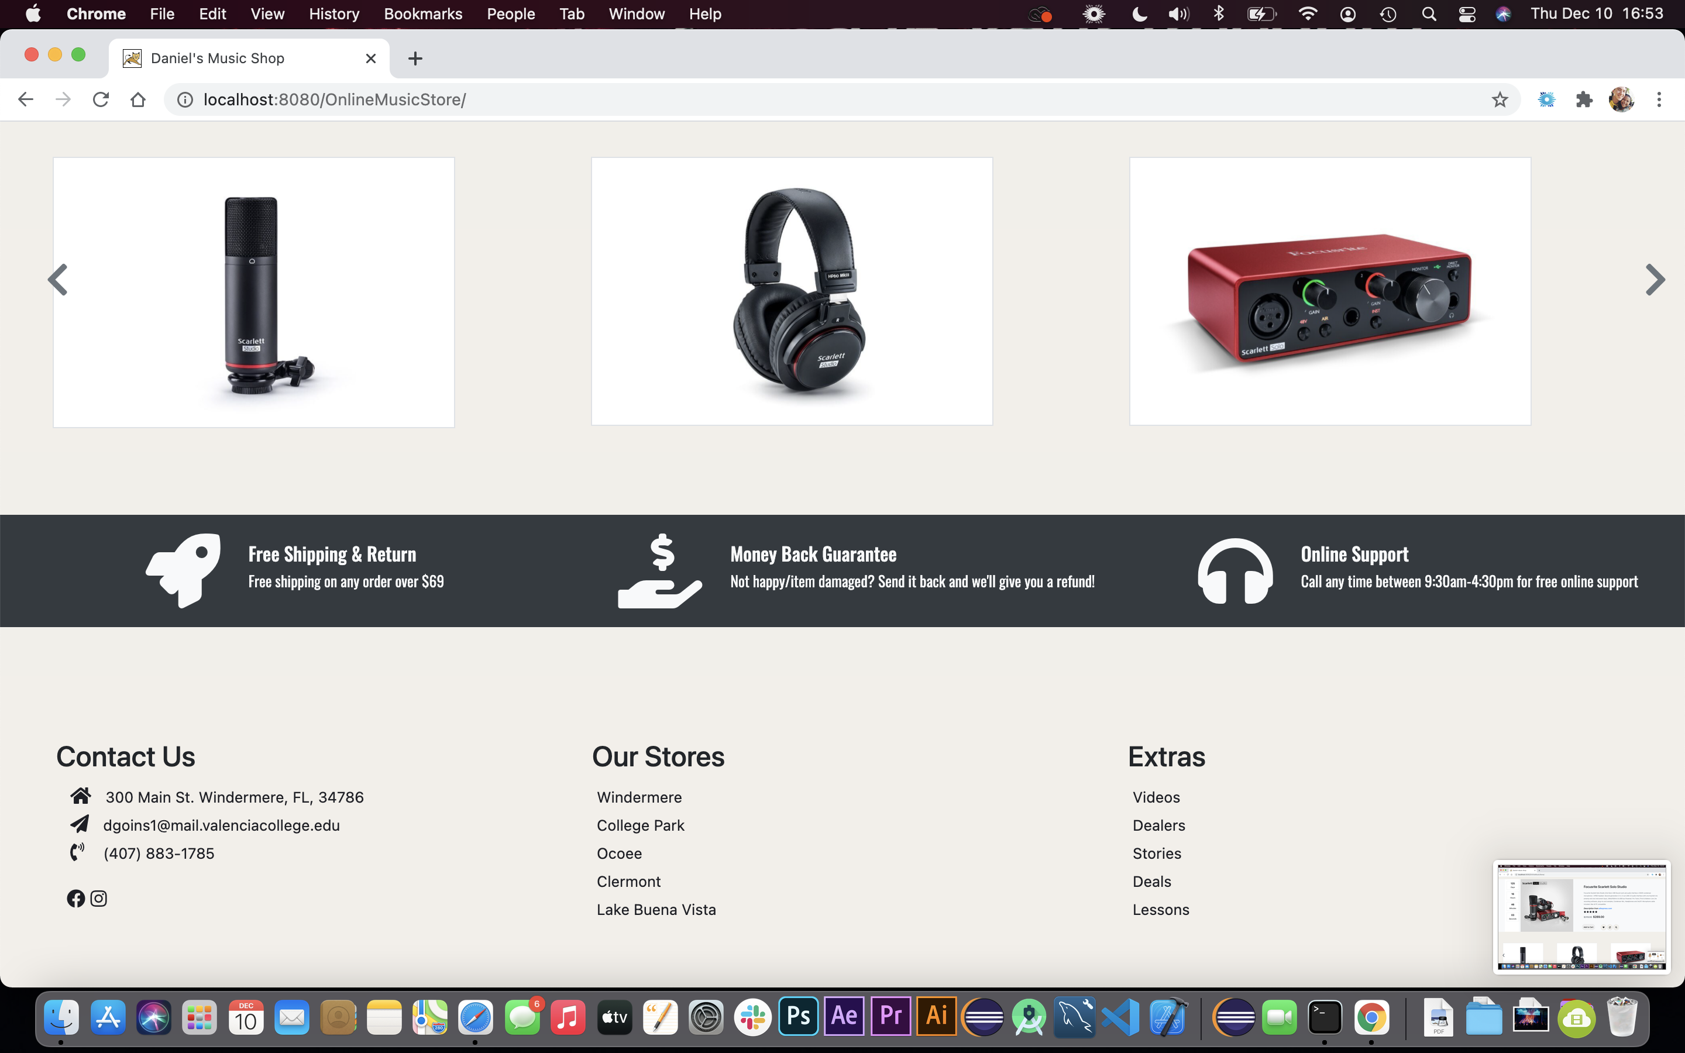

When the shopping cart icon is clicked, the user is taken to a shopping cart page where they can see a list of items in their cart, as well as an updatable cart total.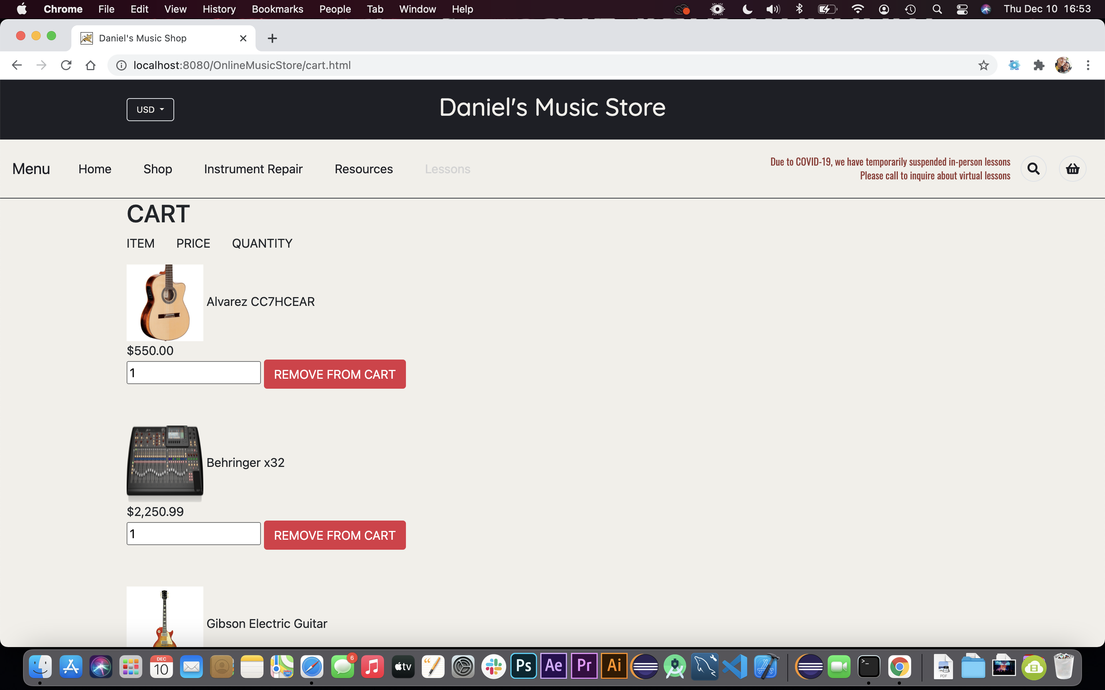

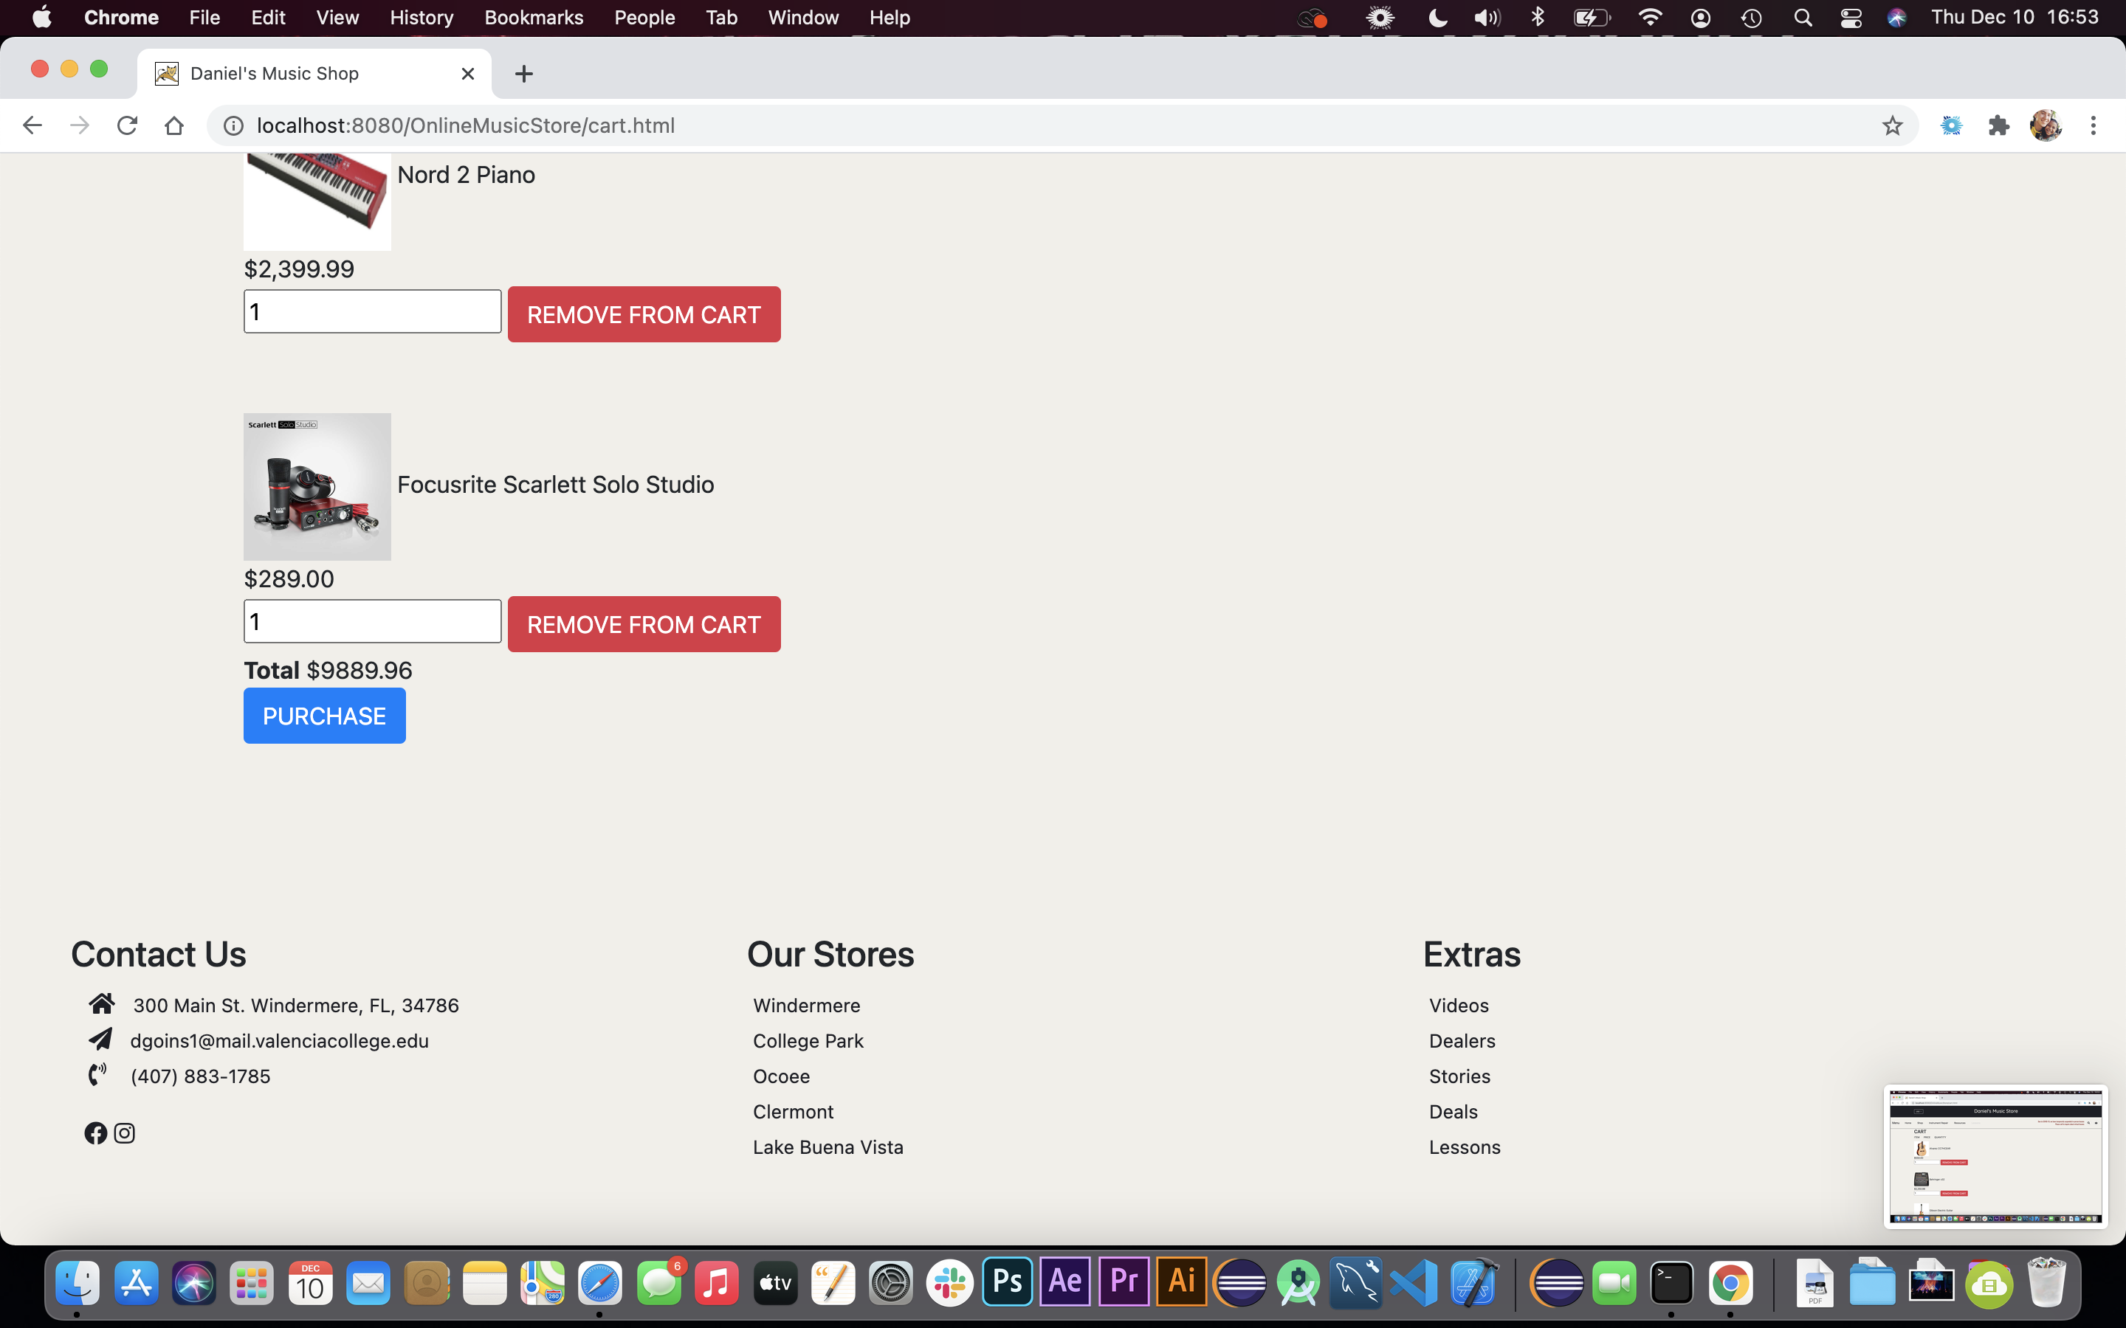

The idea was to use PHP to integrate with the database on the MAMP server, but my knowledge of PHP, MySQL, HTML, and JavaScript left much to be desired. However, the database was created, with tables for users, admins, and of course products.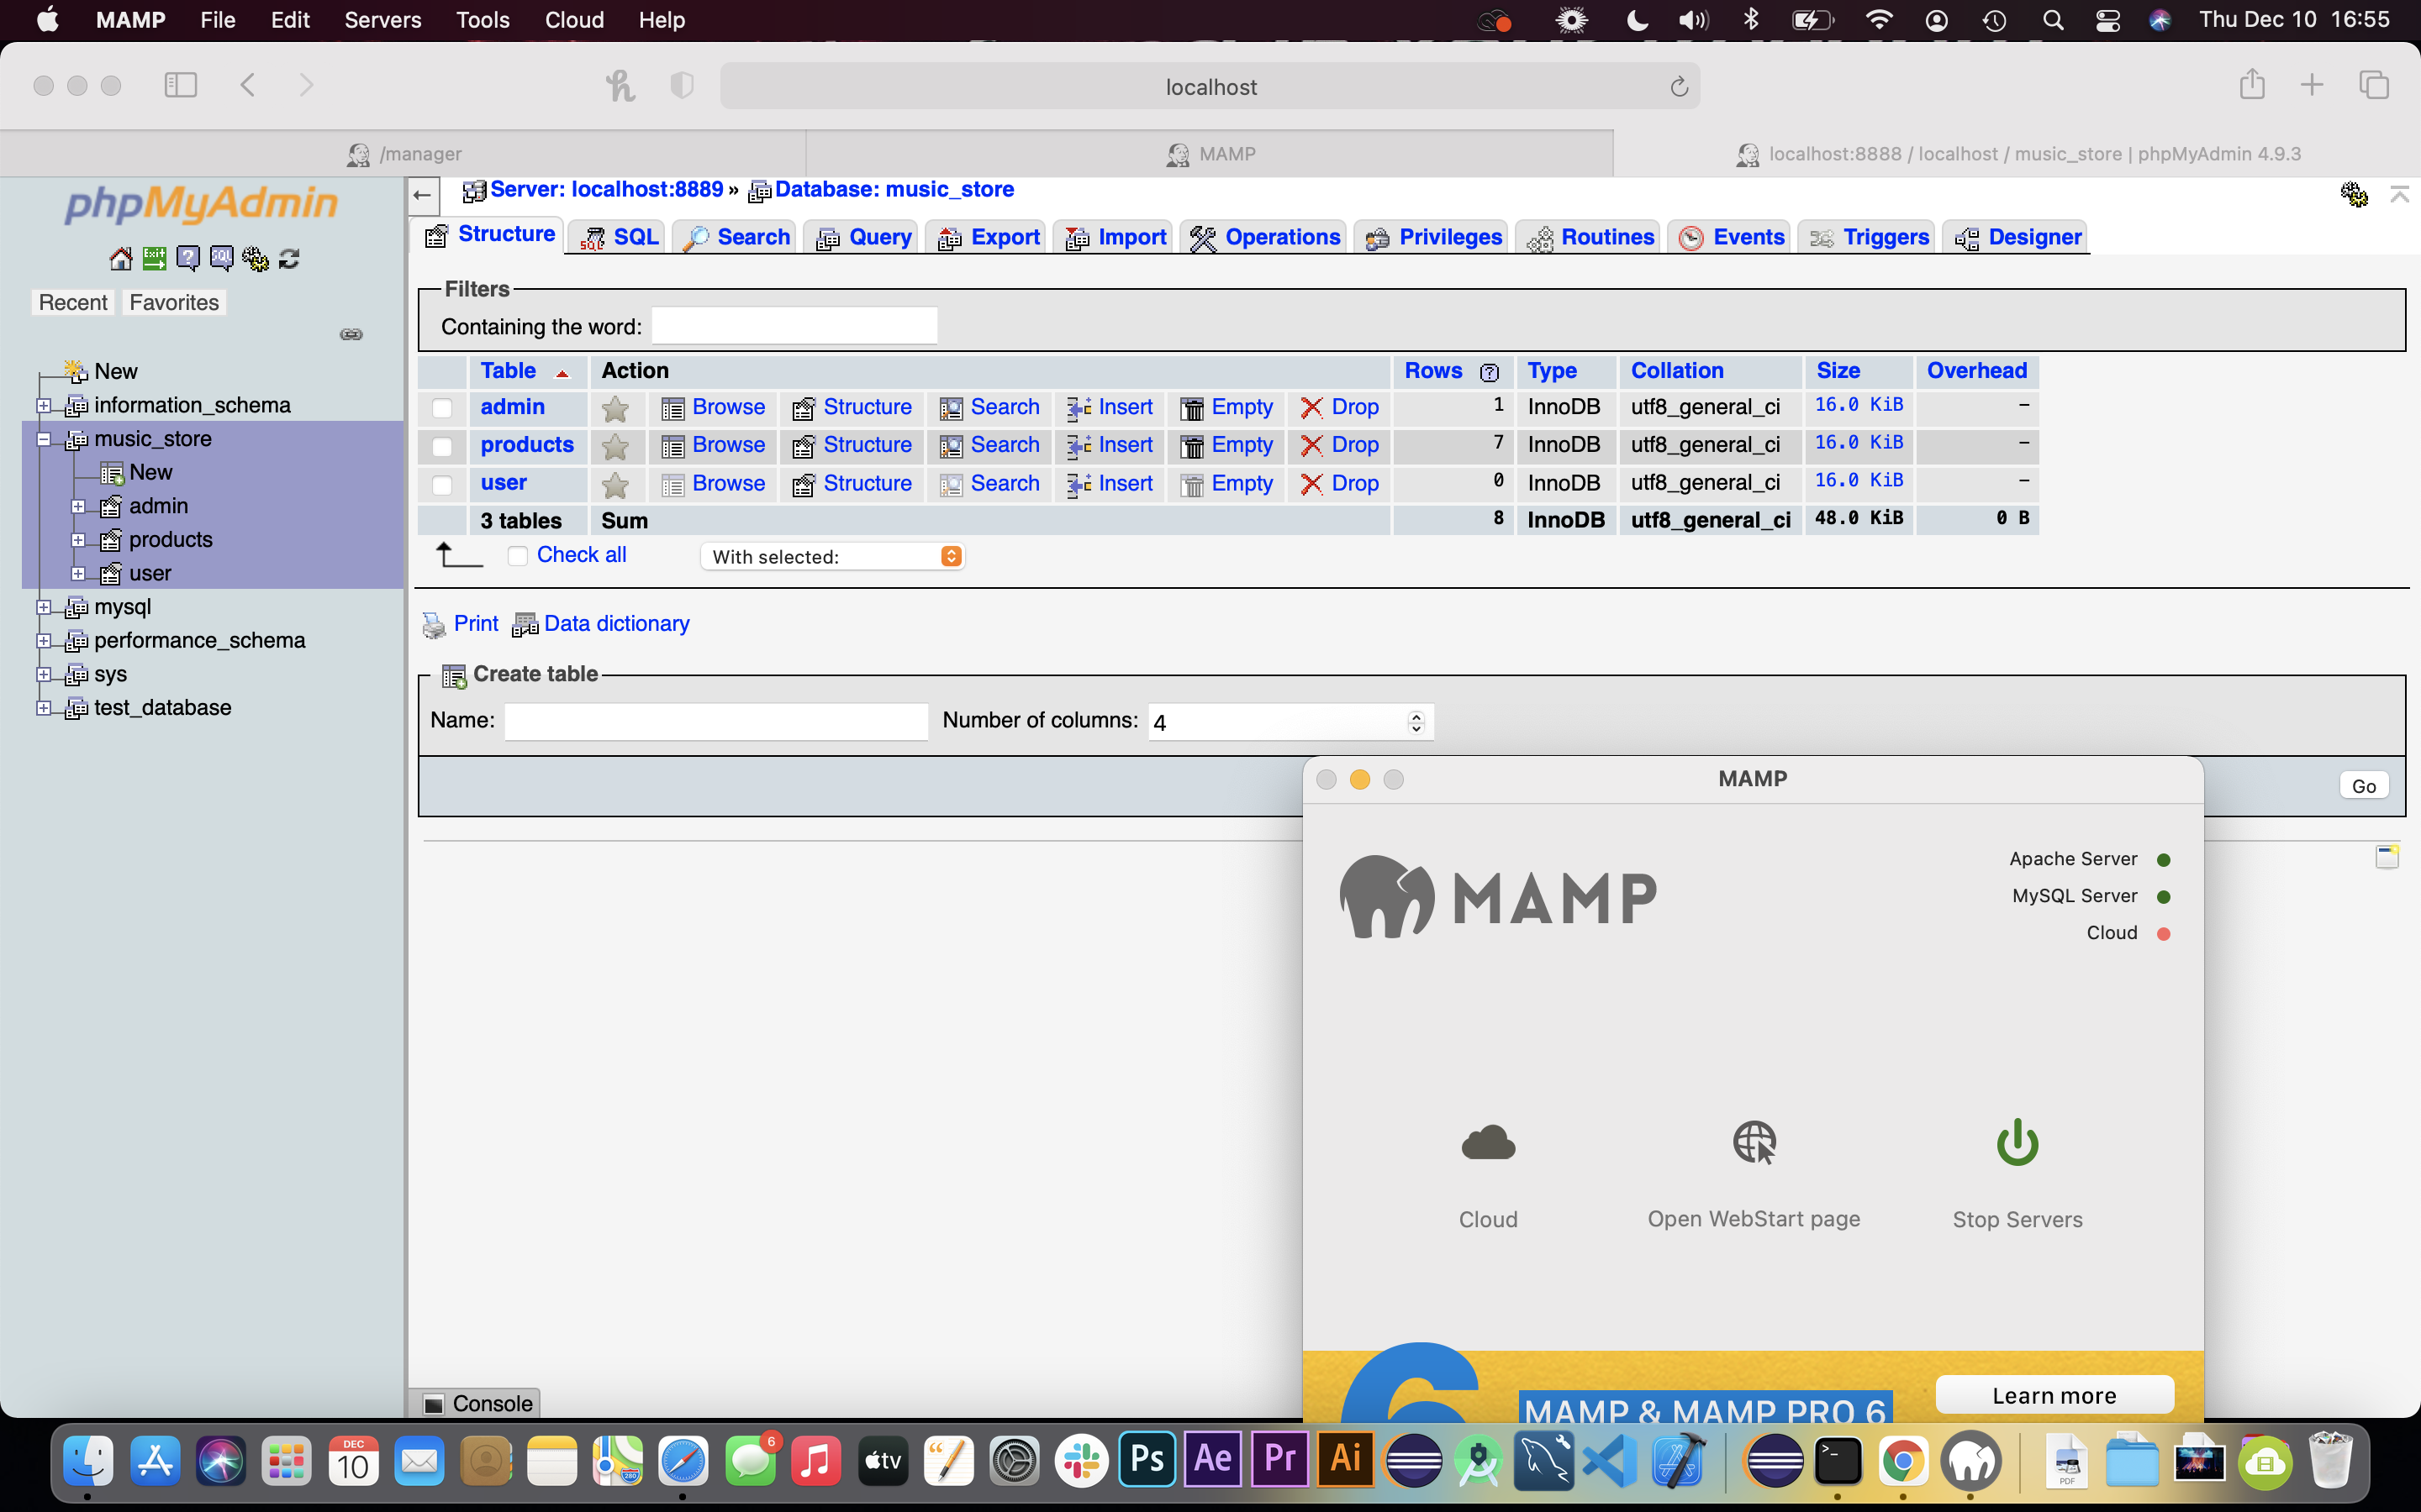

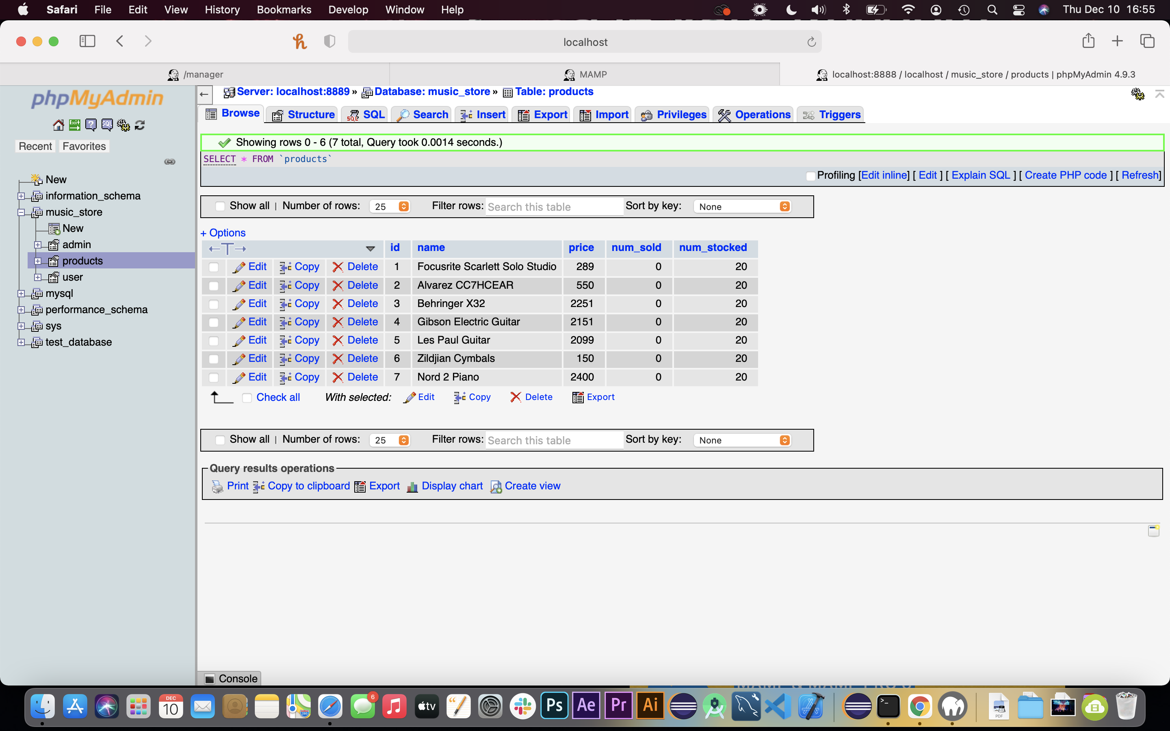

Resources used:

Udemy Course: <https://www.udemy.com/share/101HwuAEQZcV1WRnw=/>

YouTube Videos:[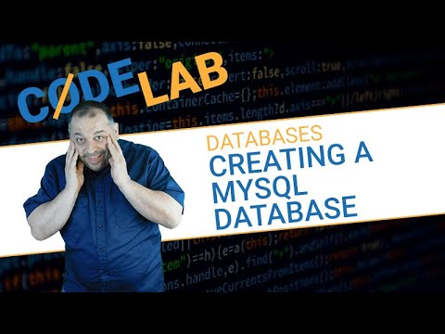](https://www.youtube.com/watch?v=tz5iWA9tbpE)[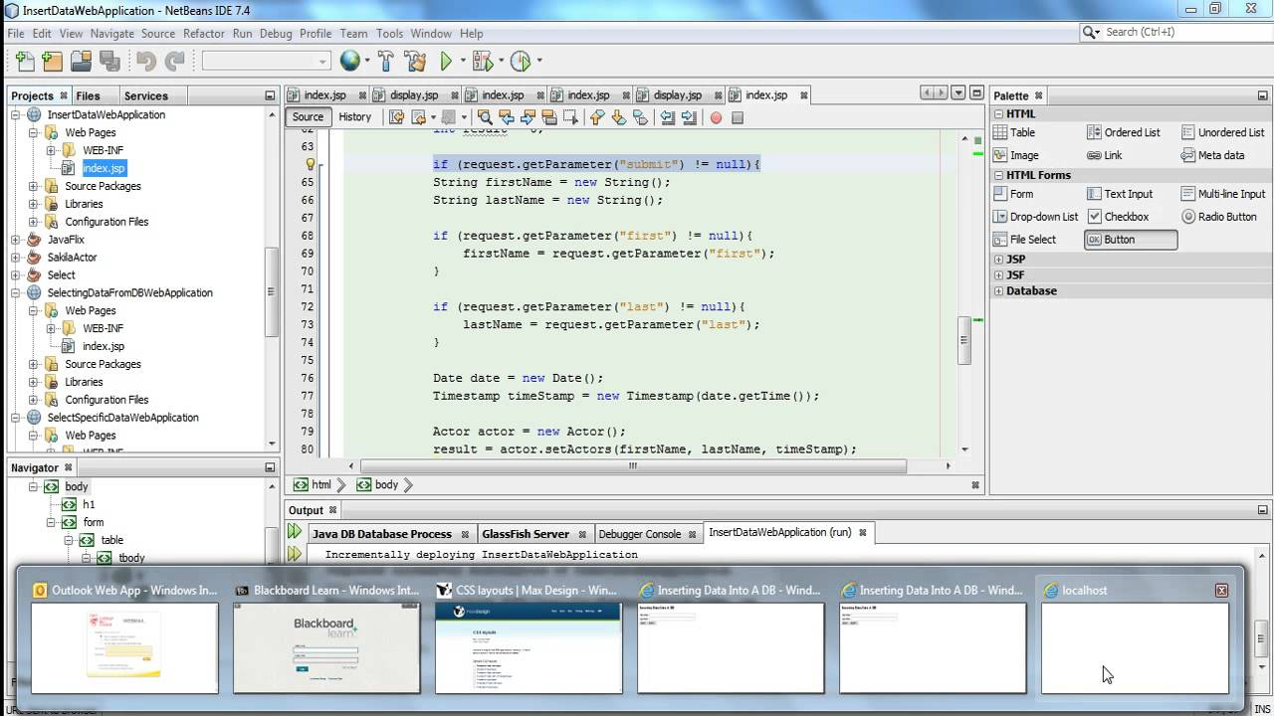](https://www.youtube.com/watch?v=8Cag7UnGo_I)[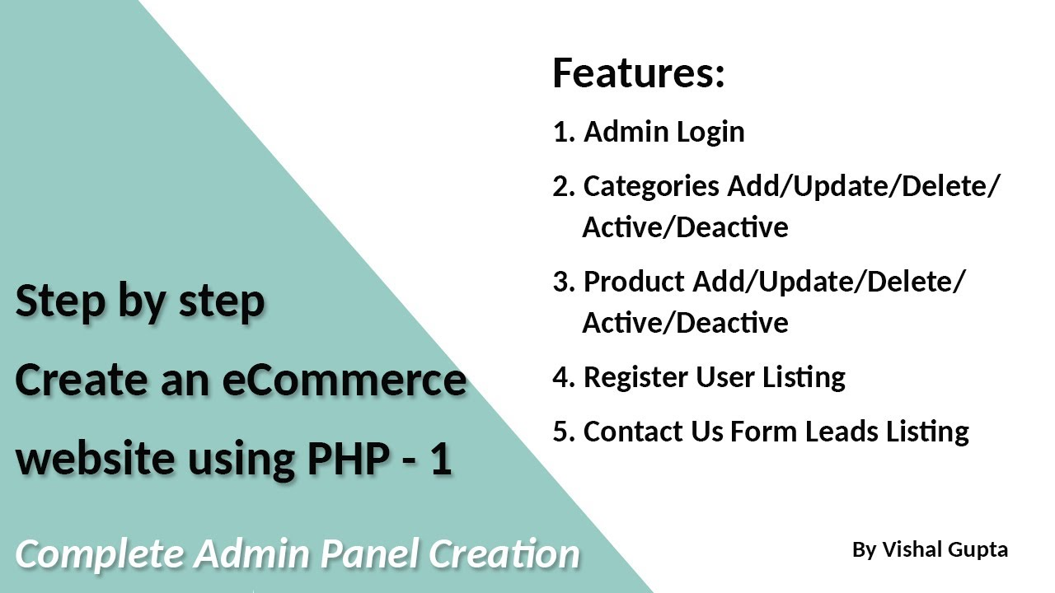](https://www.youtube.com/watch?v=QsAVoLPqkRQ)[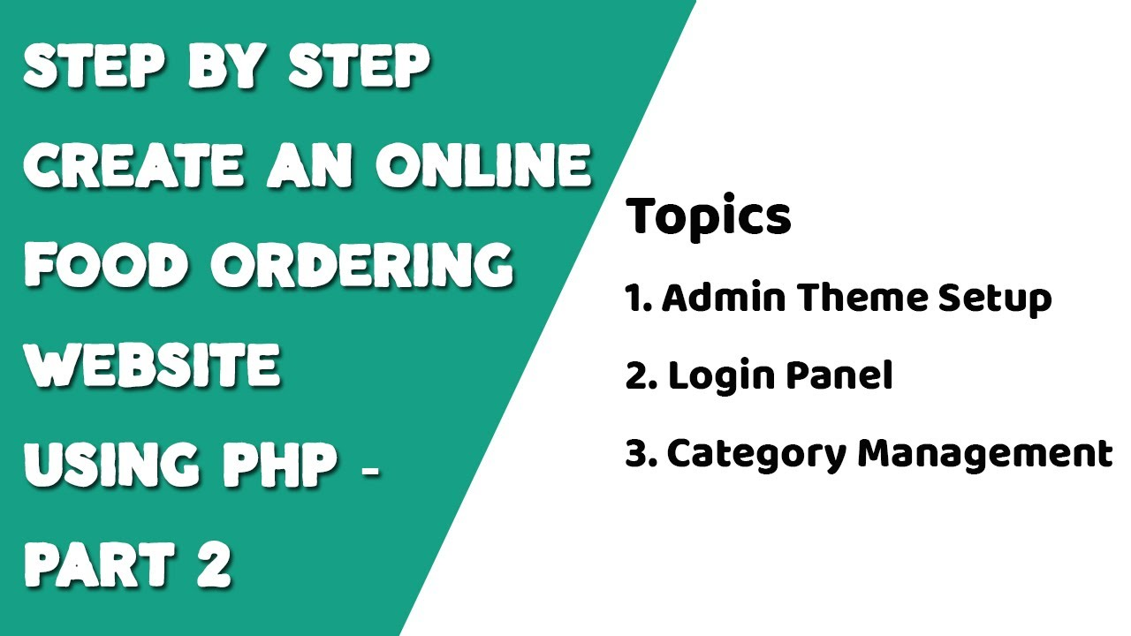](https://www.youtube.com/watch?v=eOkfHYMnmkU)[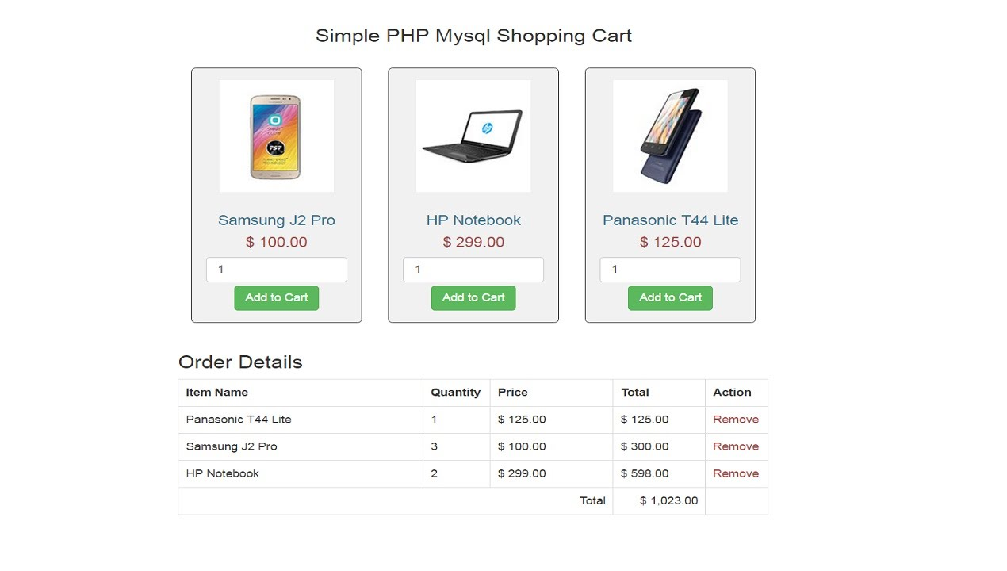](https://www.youtube.com/watch?v=0wYSviHeRbs)[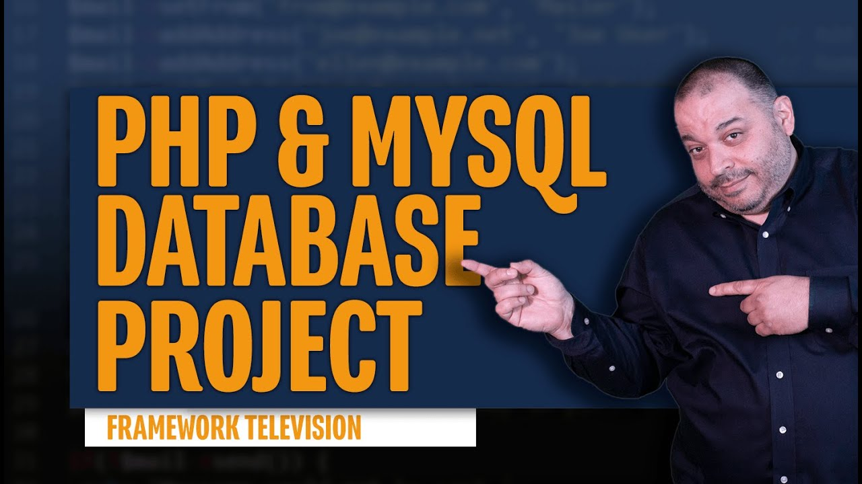](https://www.youtube.com/watch?v=yNolUEBE3Wc)[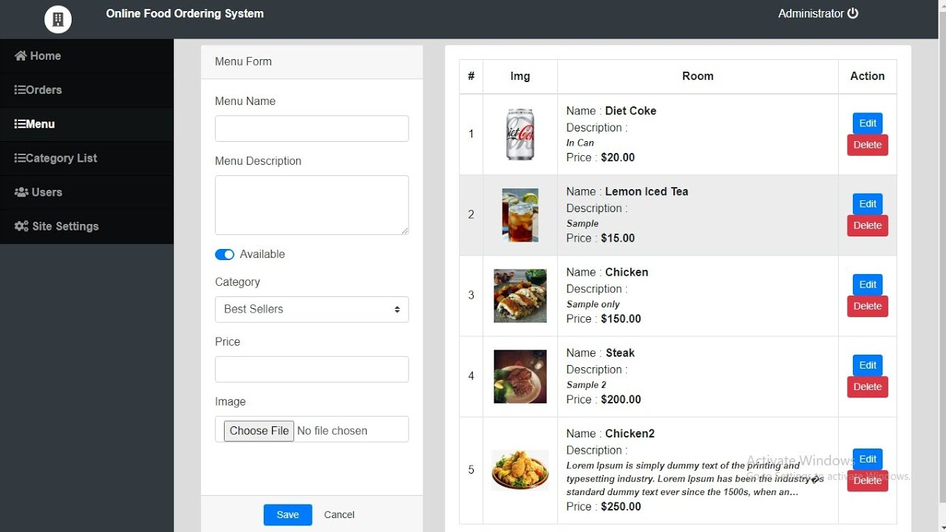](https://www.youtube.com/watch?v=vuqiFE5X9x0)[](https://www.youtube.com/watch?v=YeFzkC2awTM)[](https://www.youtube.com/watch?v=JPFrxV1TVfM)[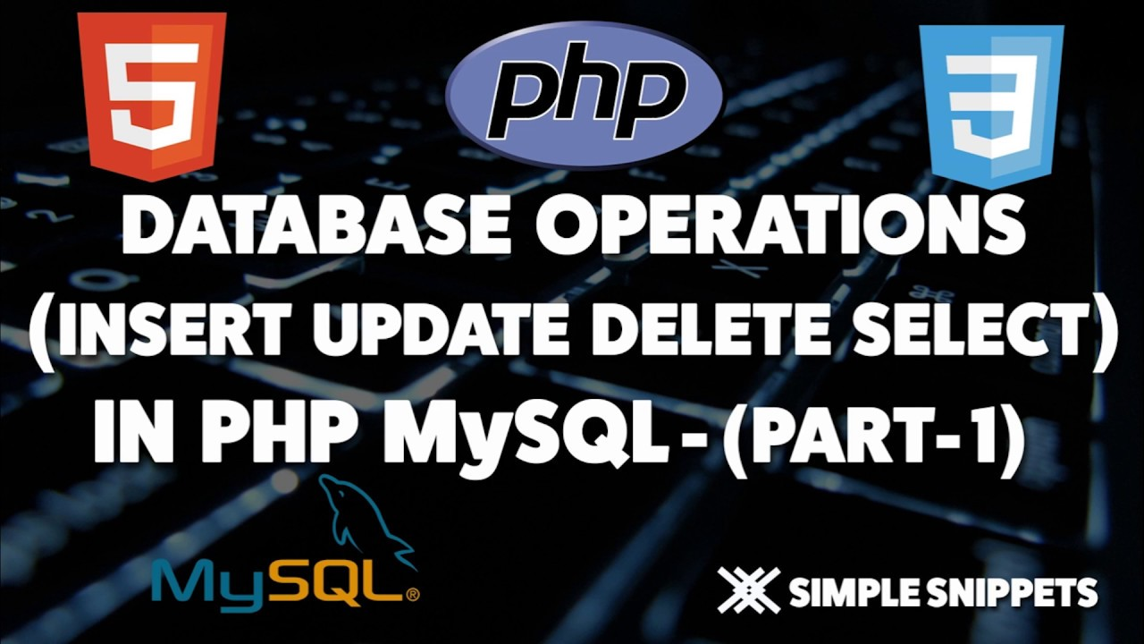](https://www.youtube.com/watch?v=beNNk5uDLqM)[](https://www.youtube.com/watch?v=n7c5zMk8cx4)[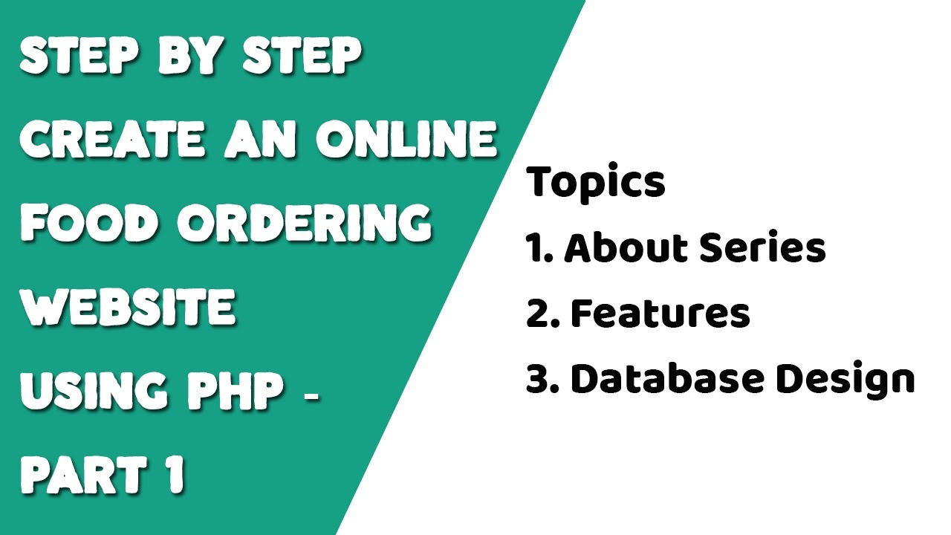](https://www.youtube.com/watch?v=x6ZeMNU8yvg)

[Installing MAMP/XAMPP](https://www.youtube.com/watch?v=qQDv6ANxd38&t=68s)

[(Links to an external site.)](https://www.youtube.com/watch?v=qQDv6ANxd38&t=68s)

[Java webapp](https://netbeans.org/kb/docs/web/mysql-webapp.html)

[(Links to an external site.)](https://netbeans.org/kb/docs/web/mysql-webapp.html)

[CRUD using PHP](https://www.taniarascia.com/create-a-simple-database-app-connecting-to-mysql-with-php/)

[(Links to an external site.)](https://www.taniarascia.com/create-a-simple-database-app-connecting-to-mysql-with-php/)

[Create database using phpMyAdmin](https://www.youtube.com/watch?v=n7c5zMk8cx4)

[(Links to an external site.)](https://www.youtube.com/watch?v=n7c5zMk8cx4)